**Assignment 12.1**

**2.​ Problem​ ​Statement**

**This assignment is for visualization using matplotlib:**

**data to use:**

**url=** [**https://raw.githubusercontent.com/Geoyi/Cleaning-Titanic-Data/master/titanic_original.csv**](https://raw.githubusercontent.com/Geoyi/Cleaning-Titanic-Data/master/titanic_original.csv)**'**

**titanic = pd.read_csv(url)**

**Charts to plot:**

1. **Create a pie chart presenting the male/female proportion in titanic dataset**

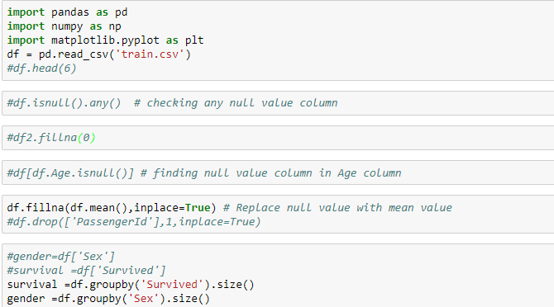

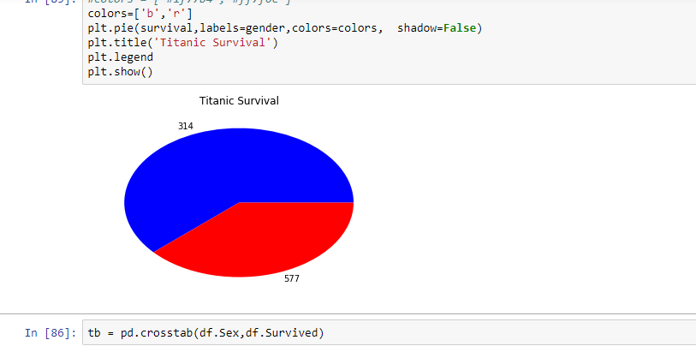

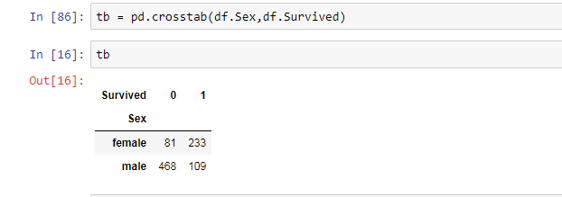

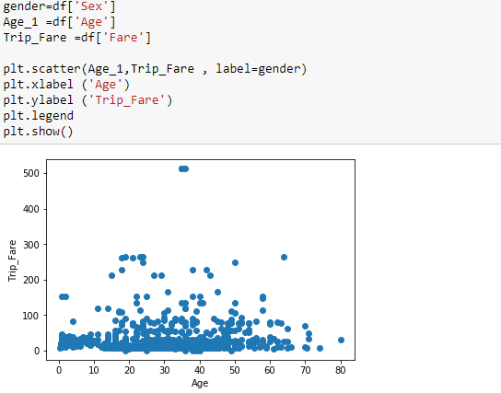

1. **Create a scatterplot with the Fare paid and the Age, differ the plot color by gender**

